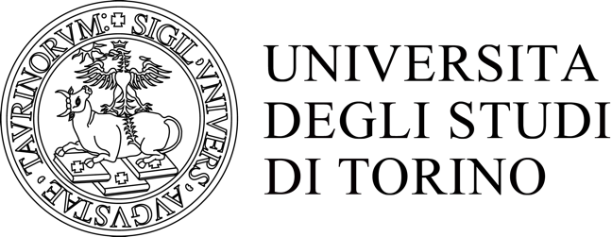

PhD Programme in
Complex Systems for Quantitative Biomedicine
(former Complex Systems for Life Sciences)

Special project: grants for Students

Subject:

Reason of the request:

Period of time:

Estimate of costs:

NB: Please remember to attach a brief letter of support from the Tutor.
Deadlines summary:
1st deadline: 28th February 2021 (requests examined 1st week of March)
2nd deadline: June 30, 2021 (requests examined 1st week of July)
3rd deadline: October 31st 2021 (requests examined 1st week of November)

In order to participate, send the requested documentation to dottorato.csls@unito.it putting in cc danilo.lombardi@unito.it.

